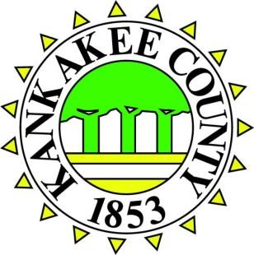

OFFICE OF THE
KANKAKEE COUNTY RECORDER
LORI GADBOIS 189 E. Court St., 2nd Fl.
RECORDER Kankakee, IL 60901
LGadbois@K3County.net 815-937-2980
March 25, 2022

PRESS RELEASE
for immediate release

KANKAKEE COUNTY RECORDER LEADING EFFORT TO PURGE
PROPERTY RECORDS OF RACIALLY RESTRICTIVE DEEDS & COVENANTS

KANKAKEE COUNTY, ILLINOIS Kankakee County Recorder Lori Gadbois has announced an initiative to remove discriminatory and racially restrictive deeds and covenants from the County’s property records. Historically, racially restrictive covenants were used to advance segregation and prevent the sale, transfer or rental of property to specific racial, ethnic or religious groups. A new State law (55 ILCS 5/35048) that took effect on January 1, 2022, sets forth a process for property owners to submit a petition requesting redaction of the unlawful restrictive covenants.
Recorder Gadbois has initiated an internal review of property records to identify deeds that contain such unlawful restrictions. Gadbois commented that “in 1948 the United States Supreme Court in the case of Shelley v. Kraemer ruled that racially restrictive covenants violate the Equal Protection Clause of the 14th Amendment. 74 years later we finally have the ability to remove these covenants for all time. To advance that cause, I will be asking that the County Board waive the recording fees for corrected deeds; we are working closely with the State’s Attorney’s Office to ensure an expedited review and filing of the corrected deeds; and my Staff and I are available to anyone desiring more information on the process.”
While the process must be initiated by the property owner, there are resources available through the Recorder’s Office to assist them. Property owner’s may obtain a copy of their property’s chain of title to search for the unlawful restrictive covenants by visiting the Recorder’s Office during normal business hours or hiring a title company to do a complete title search. Deputy Recorders remain ready to assist or answer any questions. If a property owner discovers an unlawful restriction on their property, they may begin the process necessary to correct the Deed (a Restrictive Covenant Modification Petition) by visiting www.K3CountyRecorder.com located in the forms tab.
“We want to make this as easy and streamlined of a process as possible. Racial covenants may no longer be enforceable, but they are a painful relic of segregation, racism and discrimination in all of its worst forms. There are parcels in Kankakee County with covenants that sought to prohibit AfricanAmericans, non-Whites, those of Jewish ethnicity and faith, and others from owning or renting property. While these modifications cannot undo the historical impact of such ignorance, we will be a better County without them in our records going forward. I am proud of my Office for taking the lead on this initiative locally, and I look forward to advancing this cause for Kankakee County”, said Gadbois.
For additional information on the initiative and process, contact the Recorder’s Office at (815) 937-2980.
###

